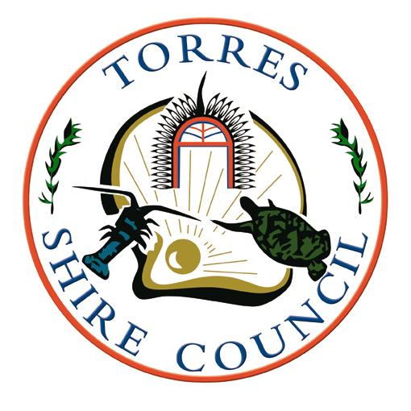 | TORRES SHIRE COUNCIL  To lead, provide & facilitate a sustainable, safe and culturally vibrant community | P O Box 171  THURSDAY ISLAND 4875  Telephone (07) 4069 1336  Facsimile (07) 4069 1845  Email: admin@torres.qld.gov.au  ABN 34 108 162 398

Torres Strait Community Sport and Recreation Program (“TSCSRP”)
Small Grants Program

Program
Council has funding available to support Torres Strait residents who resides in the Torres Shire and Torres Strait Island Regional Council Local Government Area and wish to attend cluster / regional / state level organised competitions.

Eligibility
Applications are open to all Torres Strait resident inviduals. Costs that can be supported include travel and accommodation and entry fees to competitions. The TSCSRP does not have funding support available for teams to attend carnivals.

Application Process
Council will soon open applications under this program. Individuals wishing to access support will need to complete an application form. All applications will be reviewed by an assessment committee against the stated assessment criteria.
All payments will be made by Purchase Orders on behalf of the successful applicants, there will be no cash transfer payments.

Assessment Criteria
Perference will be given to those applications, that in the opinion of the assessment committee score the highest against the assessment criteria.

The assessment criteria are based on

50% - Provide evidence that you have been selected to participate in a cluster and/.or regional and state competitions
25% - Evidence that other fund raising support has been sought.
15% - Resident of the Torres Shire Council and TSIRC Local Government Area (evidence of Local Fare Scheme Letter)
10% - Otherwise unsupported (will the applicant be able to attend if not for our funding)

Assessment Panel
TSC – Sport and Recreation Coordinator
TSC – Manager, Business Services
TSIRC – Delegate TBC

Authorisation – TSC Director Corporate and Community Services

 | TORRES SHIRE COUNCIL  To lead, provide & facilitate a sustainable, safe and culturally vibrant community | P O Box 171  THURSDAY ISLAND 4875  Telephone (07) 4069 1336  Facsimile (07) 4069 1845  Email: admin@torres.qld.gov.au  ABN 34 108 162 398

Torres Strait Community Sport and Recreation Program (“TSCSRP”)
Small Grants Program
Application Form

Name: ………………………………………………………………………………………..

Address: ……………………………………………………………………………………..

…………………………………………………………………………………………………

Purpose of funding: (eg travel, accommodation, etc)

……………………...………………………………………………………………………….

Amount of funding sought: $........................................................................................

Please describe the sport and event you seek funding for: …………………………….

…………………………………………………………………………………………………

…………………………………………………………………………………………………

…………………………………………………………………………………………………

…………………………………………………………………………………………………

…………………………………………………………………………………………………

…………………………………………………………………………………………………

What other fundraising activities have been done to support this application? ……...

…………………………………………………………………………………………………

…………………………………………………………………………………………………

…………………………………………………………………………………………………

…………………………………………………………………………………………………

…………………………………………………………………………………………………

…………………………………………………………………………………………………

What will happen if this funding it not approved? ………………………………….…...

…………………………………………………………………………………………………

…………………………………………………………………………………………………

…………………………………………………………………………………………………

…………………………………………………………………………………………………

…………………………………………………………………………………………………

…………………………………………………………………………………………………

Please attach documents to confirm you have been accepted to participate in a cluster/regional or level organised sport competition. A copy of your Local Fare Scheme Letter needs to be attached also to confirm that you are a resident living in the Torres Strait Region.

.

Additional documents attached? YES NO

Applicant Signature Date:

Witness Name & Signature Date:

