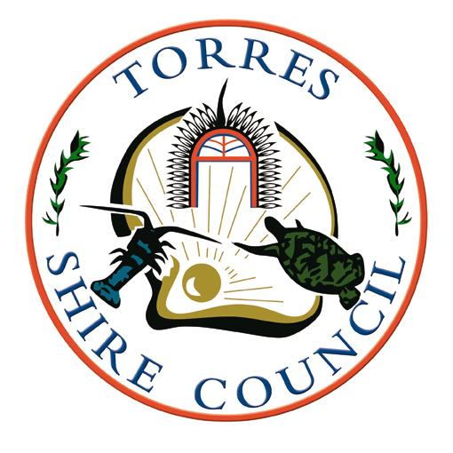 | TORRES SHIRE COUNCIL  To lead, provide & facilitate | P O Box 171  THURSDAY ISLAND 4875  Telephone (07) 4069 1336  Facsimile (07) 4069 1845  Email: admin@torres.qld.gov.au  ABN 34 108 162 398

Submission in relation to
Proposed Torres Shire Council Local Government Infrastructure Plan
This document is a submission under the Planning Act 2016
Full Name

Residential or Business Address

Address for service
(postal or email)
Grounds
Facts and Circumstances
Signed | Date / /
If you require more space, please turn over
Facts and Circumstances
Signed | Date / /
If you require more space, please use another submission sheet

